Mongolian Seterlekh Ceremony
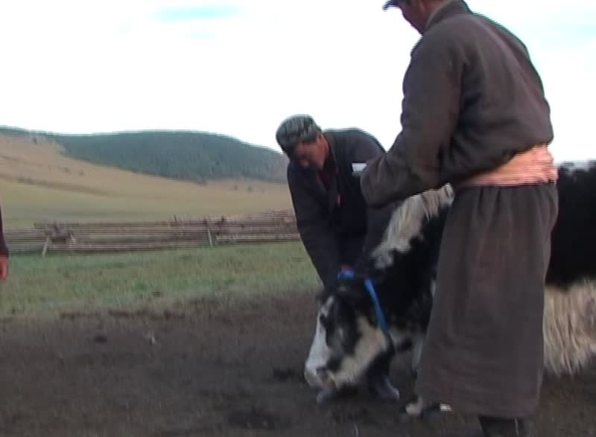

identifier
ea9aa8b8-f689-4765-9242-04dc67038986

creator
Fijn, Natasha

type
Moving Image

coverage
Mongolia

description
The seterlekh ceremony is an anti-sacrifice, where an individual animal is liberated from being killed for meat. A blue sash signifies that a seter, or sacred animal, has been dedicated to the eternal sky. The golden-robed lama in this sequence had previously indicated to the herding family that the holy animal was to be a female yak (or sarlag) that was young and dark in coat colour. Only Buddhist monks who have studied specific Tibetan Buddhist texts are allowed to conduct such a ceremony. The herder is asked to speak directly to the cow, making a verbal pact that the family will not kill her and that she must aid as protector. Under everyday circumstances herders do not speak to individual herd animals in Mongolian but use calls and commands specific to the kind of animal. Because this individual has greater power than the average yak cow, it is assumed that she will understand her instructions. The individual cow then functions as protector of both the family and the rest of the herd.

publisher

source
<https://vimeo.com/143509395>

rights
<https://creativecommons.org/licenses/by-nc-nd/3.0/>

subject
Buddhism
blessing
ceremony
cow
lama
pastoralisms
seter
yak

date
2015-10-25

language
Mongolian

format
video/mp4

contributor

original filename
Mongolian Seterlekh Ceremony.mp4

remote embed url
https://player.vimeo.com/video/143509395

relation

extent
254.360000
59.1MiB

